**1. INTRODUCTION**

**1.1 MOTIVATION**

“Knowledge is Power”- This piece of philosophical jewel was bestowed upon us by our fore-fathers and it’s never been truer than it is in this 21’st century. What we live in now is called the information age, and the need for information has indeed never been as much as it is now.

Many a times, when we require information we simply search it over the internet. But what about the people who don’t have access to internet (GPRS/Broadband), or perhaps those people who do not know how to use GPRS facility? Shouldn’t even these people to entitled to information?

This is where the unavailability of Information arises, especially in rural areas (70% in India) where people either cannot access internet or are too ignorant to use it. If we are to empower every corner of our country with easy means of accessing information, then there should be a cheap way of doing so until broadband infiltrates. Until then, we need a stop-gap solution.

**1.2 INTERNET SCENARIO IN INDIA**

Cities in India show high internet users, but it’s still the villages that are lagging far behind. Although the urban areas constitute only 30 % of India’s population, a survey shows that internet usage in these urban areas is 64 % while the usage in the 70 % Indian villages is only 36 % (Reference-Website 7.2.1.1). This clearly reflects the bad condition of internet usage in Indian villages

DNA survey shows that 80% village folks are unaware of the Internet’s existence, and among the one’s who are aware, Of the ones who did know about it, 85% used the net only to access emails, 13% to know about the latest farming techniques and 2% to look up fertilizers, among other uses. We can acknowledge that internet penetration so far has been weak.”. (Reference-Website 7.2.1.2)

**1.3 CELL PHONE GROWTH IN INDIA**

It is mockingly said that India is a country with more mobile phones than public toilets.

India added 17 million cell phone subscribers in July 2010, taking total number to 652 million, (TRAI).This figure is only going to increase as cell phone infiltrates every nook and corner.

To go by recent figures India’s latest population is estimated around 1,198,003,000. Of this we are adding close to 15 million mobile users on average in a month, while in case of Internet it is 14 million users a year. Of course, it is not fair to compare the two, but this shows how slowly Internet is gaining traction, especially in the rural sector.

**1.4 MOBILE TELEPHONY IN RURAL AREAS**

“The quickest way to get out of poverty right now is to have one mobile telephone”- this statement was said by Muhammad Yunus, Nobel Peace Prize winner. In India Mobile telephones has been a “dream come true” for rural areas. Connectivity to the outside world has been made easy. Unnecessary commuting to urban centers has been tremendously reduced.

Today, mobile telephony is being used to provide information to the farmers through SMS. Mobile telephony offers some unique opportunities. These benefits are amplified by the fact that the spread of mobile technology in some rural regions has occurred much faster than with other information and communication technologies (ICTs). In countries such as with high rural population densities, mobile telephony has quickly become much more cost-effective for telecommunication provision. (Reference-Website 7.2.1.3)

Benefits include

• Providing a direct global communication channel to rural communities

• Offers multiple formats for information in one device

• Provides accessibility for illiterate users (i.e. voice and images)

• Offers multiple formats for information in one device

• Making rural services more efficient and cost-effective.

**1.5 KNOWLEDGE VS INFRASTRUCTURE GAP**

In order to access knowledge in today’s world, one needs the internet, which in turn needs high infrastructure and connectivity. This cannot be afforded by the poor or people from the villages. However, if a developing country is to grow, it is precisely these people that it needs to empower the information to.

This leads to a catch 22 situation wherein Knowledge cannot be accessed without infrastructure and on the flip side information is needed by those people the most who cannot afford the infrastructure.

This leads to the Knowledge vs Infrastructure gap. We will see further how this gap can be bridged by means of voice telephony.

**1.6 AIMS**

* To provide wireless information
* To bridge Knowledge vs. Infrastructure gap
* To provide affordable means of information
* To take advantage of high mobile penetration, especially in rural areas
* To ensure knowledge is available in every nook and corner

**1.7 SCOPE OF THE PROJECT**

**1.7.1 Providing information to the people with access to mobile but not GPRS:**

This point emphasis on providing information to the users who possessed low end cell phones which are not GPRS enabled. These type of cell phones are accompanied with facilities such as call making, call attending, SMS sending, SMS receiving etc.

**1.7.2 Relaying information to places where Connectivity/Infrastructure is not available:**

This point emphasizes on relaying information to users who do not have INTERNET access because of the lack of infrastructure at the place. These users are deprived of a huge knowledge database in form of INTERNET because of the distant placing from main metros.

**1.7.3 Information for the visually impaired and blind:**

Visually impaired users cannot use INTERNET facility to acquire knowledge. But visually impaired User can use the SMS facility provided on the cell phones. Also ,although they cannot read information, they can listen to it over voice telephony.

**1.7.4 Cheap Means of information:**

Charges required to send a SMS are much less compared to charges of INTERNET usage or GPRS usage, this will provide cheap source of information to the people who cannot afford Internet, or are too ignorant to use it.

**1.7.5 To make extracting information a finger touch away:**

Information is made available to user at a single go. User just needs to send a SMS containing a keyword regarding query and he/she will get the information on voice call. Thus the information can be accessed with just a finger touch.

**2. REVIEW OF LITERATURE**

**2.1 SENDING AND RECEIVING SMS USING AT COMMANDS:**

User will send the SMS having keyword regarding the information needed. This SMS will be received by the modem enabled cell phone connected to dedicated server. Then this SMS will be extracted by the server using AT commands. They are called “Attention Terminal” command.

[AT commands](http://en.wikipedia.org/wiki/AT_commands) are used to control [modems](http://en.wikipedia.org/wiki/Modem) to do their specified functions. [Cellular phones](http://en.wikipedia.org/wiki/Cellular_phone) are not much different from the old dial-up modems that are still found in many computers.The commands are sent to the phone's modem, which can be a GSM modem or PC modem. AT commands can be used for operations that are usually done from the keypad, for instance calling a number, sending, reading, or deleting an SMS, setting the SMSC number, looking for a GPRS access point, reading and deleting phonebook data, reading the battery status, reading the signal strength, and so on.

**2.1.1 How to use AT Commands:**

1. Connect the mobile phone to your PC in PC Suite mode using any available connection (Bluetooth, USB, or IR).
2. Make sure that you have installed the correct GSM modem driver on your PC. You can check it from Control Panel | System | Hardware | Device Manager. Check the Modems section. If you see something like "Nokia XY USB Modem" or "Nokia XY Bluetooth Modem", the device has a built-in GSM modem. If you don't have it, go to the Nokia Web site and download the driver from the product page of your device.

[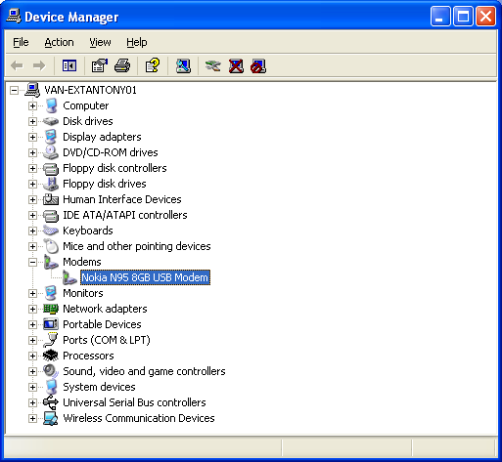](http://wiki.forum.nokia.com/index.php/File:Controlpanel_gsmmodem.png)

1. Open the HyperTerminal, which is a communication utility on Microsoft Windows OS.
   1. HyperTerminal is located in Start | Programs | Accessories | Communication.
2. Create a new connection set on HyperTerminal. You may need to set some parameters, such as baud rate (for example, 9600), handshaking mode (Xon-Xoff), parity bit (default), and so on.
3. Note that you also need to select the communication port on which your mobile has been
   1. Connected. The port number can be found by right-clicking the modem item in Control Panel.

[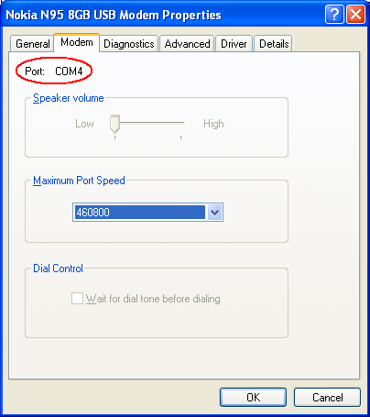](http://wiki.forum.nokia.com/index.php/File:Controlpanel_gsmmodem_port.png)

* 1. After this, you can give the basic AT command. Simply type **AT** in the window and you will get the "OK" response.

[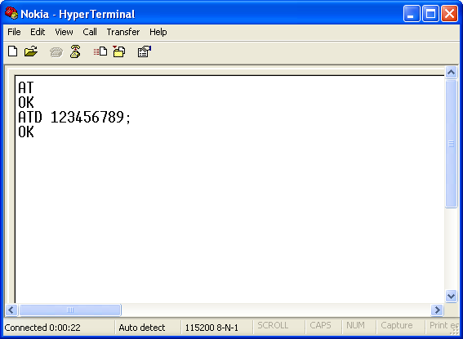](http://wiki.forum.nokia.com/index.php/File:Hyperterminal_example.png)

1. The above picture also shows how to dial a number using the ATD command. Note that there is a semi-colon (;) at the end of the phone number indicating that this is a voice call. If there is no semi-colon, a data call (CSD call) is will be performed.

# 2.1.2 AT commands set for Nokia GSM

|  |  |  |
| --- | --- | --- |
| Command |  | Description |
| ATA |  | Answer command |
| ATD |  | Dial command |
| ATM |  | Monitor speaker mode |
| ATO |  | Go on-line |

**2.2 EXTRACTION AND PARSING:**

Information is obtained in form of HTML output. This information cannot be relayed to user as it is because of the following problems

* It will contain a lot of information which will become cumbersome for the user to listen
* Conversion of such a lot of text into speech will take a lot of time
* Most of the times the main information is contained only in the summary

**2.2.1 Testing Wikipedia with keywords**

After testing 30 words we saw that summary contains 240-280 words, hence it is ideal to convert while it still has the necessary information. Also it was observed that the information is most of the time in constant format which makes it easier to parse it since the HTML keywords have a constant formatting. Information obtained from Wikipedia is in following format:

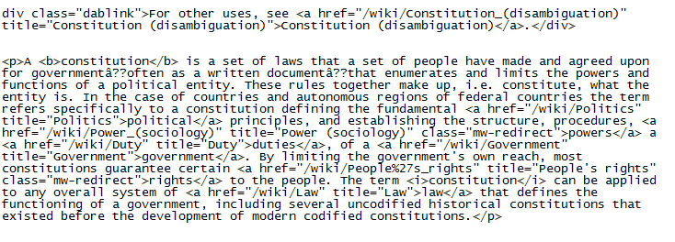

The summary we have obtained in HTML format will now be parsed, this is done to eliminate the tags and to keep only the relevant summary. This parsing will be done by manipulating strings through java. The final parse will contain only that information which is to be converted in speech

**2.3 TEXT TO SPEECH API**

**2.3.1 What is API**

An Application Programming Interface (API) is an interface that a software program that implements in order to allow the software to interact with it; much in the same way that software might implement a user interface in order to allow humans to interact with it.APIs are implemented by applications, libraries and operating system to define how other software can make calls to or request services from them

**2.3.2 Java Speech API**

After parsing of the web page, information which needs to be delivered to user in voice format is available on the server. This Text to Speech conversion is done using Java Speech API.The Java Speech [API](http://en.wikipedia.org/wiki/Application_Programming_Interface) specifies a cross-platform interface to support command recognizers, dictation systems and speech synthesizers. The Java Speech API Mark-up Language (JSML) and the Java Speech API Grammar Format (JSGF) are companion specifications to the Java Speech API. JSML (currently in beta) defines a standard text format for marking up text for input to a speech synthesizer. JSGF version 1.0 defines a standard text format for providing a grammar to a speech recognizer. Both specifications are available at

The Java Speech API allows you to incorporate speech technology into user interfaces for your applets based on Java technology. Two core speech technologies are supported through the Java Speech API: speech synthesis and speech recognition. In our project’s scope we will be using only Speech synthesis technology supported by Java Speech API.

**2.3.3 Speech synthesis using java speech API**

Speech synthesis provides the reverse process of producing synthetic speech from text generated by an application, an applet, or a user. It is often referred to as text-to-speech technology.

The major steps in producing speech from text are as follows:

* Structure analysis: Processes the input text to determine where paragraphs, sentences, and other structures start and end. For most languages, formatting data are used in this stage.
* Text pre-processing: Analyzes the input text for special constructs of the language. In English, special treatment is required for abbreviations, acronyms, dates, times, numbers, currency amounts, e-mail addresses, and many other forms.

The remaining steps convert the spoken text to speech:

* Text-to-phoneme conversion: Converts each word to phonemes (basic unit of sound ).
* Prosody analysis: Processes the sentence structure, words, and phonemes to determine the appropriate prosody for the sentence.
* Waveform production: Uses the phonemes and prosody information to produce the audio waveform for each sentence.

Speech synthesizers can make errors in any of the processing steps described above. Human ears are well-tuned to detecting these errors, but careful work by developers can minimize errors and improve the speech output quality. In this way information related to the query given by User will be converted to speech. This information will now be relayed back to the user using AT commands.

* 1. **WIKIPEDIA**

**2.4.1 Why Wikipedia**

Wikipedia the free encyclopedia that anyone can edit. Wikipedia's articles provide links to guide the user to related pages with additional information. Wikipedia is [written collaboratively](http://en.wikipedia.org/wiki/Collaborative_writing) by  [Internet volunteers who write without pay](http://en.wikipedia.org/wiki/Wikipedia:Wikipedians) (except where editing is restricted). Since its creation in 2001, [Wikipedia](http://en.wikipedia.org/wiki/Wikipedia) has grown rapidly attracting nearly [78 million visitors](http://siteanalytics.compete.com/wikipedia.org?metric=uv) monthly as of January 2010. Wikipedia is open to a large contributor base, drawing a large number of editors from diverse backgrounds. This allows Wikipedia to significantly reduce regional/cultural bias. The features why we chose Wikipedia are:

* Assigning Boundaries for information search over the vast internet pool
* It is open source (free)
* It has Regularly updated Database
* It has a constant format, which makes it easier to parse information
* It is Reliable, since it is a moderated website
  + 1. **Errors in searching Wikipedia**

Errors are generated if

* + - 1. User enters wrong spelling

The server cannot do anything in this case except send back a prompt to the user saying that he/she has entered an incorrect spelling

2.4.2.2 No word exists in the database

Again the server is not at fault if the word the user asked for is not found in the database. In this case the server will prompt the user that the word he requested was not found in the database.

2.4.2.3The word is ambiguous

Some words have multiple meanings when entered for search.E.g.:- mercury is ambiguous in the sense that it can either mean mercury as a planet or mercury as an element. In this case the user will have to enter the additional information within parenthesis e.g. he can enter either Mercury (planet) or Mercury (Element)

In case of ambiguity, detected by the server, the first word in the list will be considered by default for the search of keyword.

* + 1. **Format of standard Wikipedia page**

The standard Wikipedia page will contain title, summary, description list, and main description. This will help when parsing the page for information from a particular section

* 1. **DATABASE**

Summary content to be stored in DB in FIFO manner. The question arises as to how to decide the cache size. The proposed solution, at least till the design phase is as follows

10 KB page size + 500 hits per day = 5 MB cache size

The proper estimation of the cache can only be done after the testing phase.

**3. ANALYSIS**

**3.1** **EXISTING SYSYTEM**

There are many Existing Systems available for information gain. An User can make use of these Systems and acquire knowledge regarding the queries he/she has.

Following are some of the existing resources available to User for knowledge retrieval.

**3.1.1 Internet:**

The Internet is a global system of interconnected [computer networks](http://en.wikipedia.org/wiki/Computer_network) that use the standard [Internet Protocol Suite](http://en.wikipedia.org/wiki/Internet_Protocol_Suite) (TCP/IP) to serve billions of users worldwide. It is a *network of networks* that consists of millions of private, public, academic, business, and government networks, of local to global scope, that are linked by a broad array of electronic and optical networking technologies. The Internet carries a vast range of [information](http://en.wikipedia.org/wiki/Information) resources and services, such as the inter-linked [hypertext](http://en.wikipedia.org/wiki/Hypertext) documents of the [World Wide Web](http://en.wikipedia.org/wiki/World_Wide_Web) (WWW) and the infrastructure to support [electronic mail](http://en.wikipedia.org/wiki/E-mail).

**3.1.2 GPRS:**

General packet radio service (GPRS) is a [packet oriented](http://en.wikipedia.org/wiki/Packet_oriented) [mobile data service](http://en.wikipedia.org/wiki/Mobile_Data_Service) on the [2G](http://en.wikipedia.org/wiki/2G) and [3G](http://en.wikipedia.org/wiki/3G) [cellular communication](http://en.wikipedia.org/wiki/Cellular_communication) systems [global system for mobile communications](http://en.wikipedia.org/wiki/Global_System_for_Mobile_Communications) (GSM). The service is available to users in over 200 countries worldwide. GPRS was originally standardized by [European Telecommunications Standards Institute](http://en.wikipedia.org/wiki/European_Telecommunications_Standards_Institute) (ETSI) in response to the earlier [CDPD](http://en.wikipedia.org/wiki/CDPD) and [i-mode](http://en.wikipedia.org/wiki/I-mode) packet switched cellular technologies. It is now maintained by the [3rd Generation Partnership Project](http://en.wikipedia.org/wiki/3rd_Generation_Partnership_Project) (3GPP). GPRS usage charging is based on volume of data, either as part of a bundle or on a pay as you use basis.

**3.1.3 EDGE:**

Enhanced Data rates for GSM Evolution (EDGE) (also known as Enhanced [GPRS](http://en.wikipedia.org/wiki/GPRS) (EGPRS), or [IMT](http://en.wikipedia.org/wiki/IMT-2000) Single Carrier (IMT-SC), or Enhanced Data rates for Global Evolution) is a digital [mobile phone](http://en.wikipedia.org/wiki/Mobile_phone) technology that allows improved data transmission rates as a [backward-compatible](http://en.wikipedia.org/wiki/Backward-compatible) extension of [GSM](http://en.wikipedia.org/wiki/GSM). EDGE is considered a 3G radio technology and is part of [ITU](http://en.wikipedia.org/wiki/ITU)'s [3G](http://en.wikipedia.org/wiki/3G) definition. EDGE was deployed on GSM networks beginning in 2003 — initially by [Cingular](http://en.wikipedia.org/wiki/Cingular) (now AT&T) in the [United States](http://en.wikipedia.org/wiki/United_States).EDGE is standardized by [3GPP](http://en.wikipedia.org/wiki/3GPP) as part of the GSM family. EDGE delivers higher bit-rates per radio channel.

**3.2 PROBLEM STATEMENT**

As mentioned above there are many resources available to User for information gain. But there are some problems associated with those recourses. These problems can be enlisted as follows accordingly each technology.

**3.2.1 Problems with INTERNET:**

INTERENT usage is costly, and it is not affordable to common man. Service providers of INTRENET facilities such as BSNL, HATHWAY charge User according to speed and download limits. In rural areas infrastructure required to deploy this facility is not available. And moreover many of the people from distant areas are not aware of this technology and usage of it.

**3.2.2 Problems with GPRS/EDGE:**

GPRS/EDGE enabled mobile phones are mostly high end cell phones. Hence their cost is on higher side. Also in many far away places the connection of this 2G service may not be up to the standards required for normal browsing. There is also the problem of infrastructure for GPRS/EDGE, which may not be constructed in rural areas.

Hence we conclude that though there are different resources are available for knowledge gain, an User is deprived of it because of the above mentioned problems.

Thus our proposed system looks forward to make the knowledge available to User irrespective of his/her limitations of making use of existing system.

**3.3. PROPOSED SYSTEM**

This project aims at providing a System which will give solution to the above mentioned problems. In order to make use of the high internet penetration, we will be using mobile phones as agents to send and receive information. The keyword is to be sent via SMS to a number assigned to the server. The server then will extract the keyword, search it over Wikipedia, parse out all the unwanted content and keep only relevant information, then convert the information it gets into audio format and call back the user to relay him/her the information.

Let us see various representations of the system.

**3.3.1 Visual representation of system**

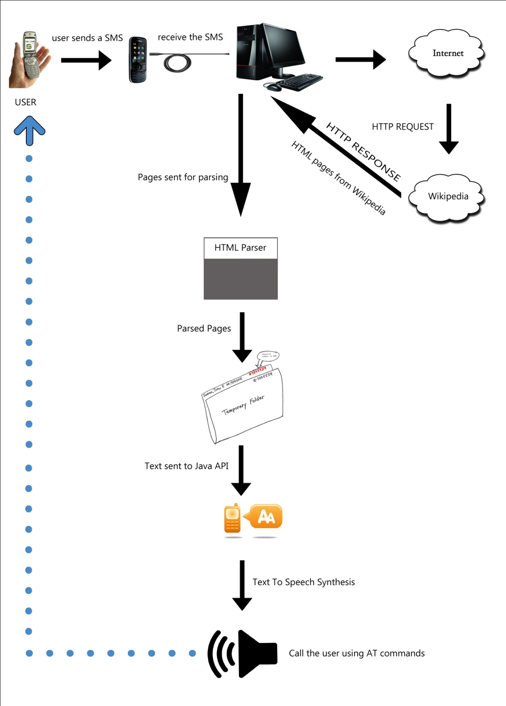

**3.3.2 Use Case Diagram**

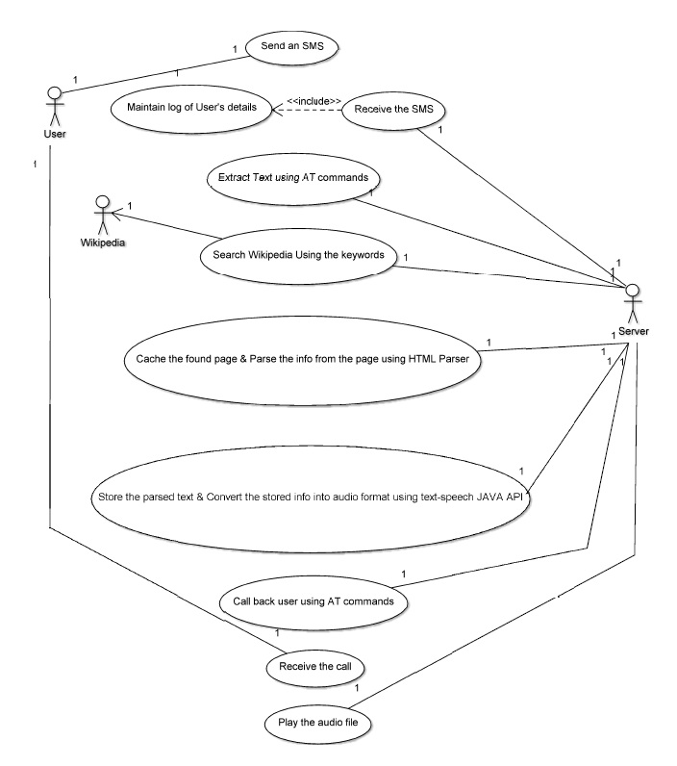

* 1. **DETAILS OF HARDWARE AND SOFTWARE**

**3.4.1 Platform:**

Open Source.

**3.4.2 Language:**

Java

**3.4.3 Hardware:**

1. GSM enabled mobile at server side

2. Internet connection-minimum 64 kbps at server

3. SMS enabled mobile at client side

**3.4.4 Software:**

1. JDK edition 1.6 update 19

2. MySQL for Database

.

**4. METHODOLOGY**

**4.1 SOFTWARE DEVELOPMENT LIFE CYCLE**

The Software Development Life Cycle in [systems engineering](http://en.wikipedia.org/wiki/Systems_engineering), [information systems](http://en.wikipedia.org/wiki/Information_systems) and [software engineering](http://en.wikipedia.org/wiki/Software_engineering), is the process of creating or altering systems, and the models and [methodologies](http://en.wikipedia.org/wiki/Methodologies) that people use to develop these systems. The concept generally refers to [computer](http://en.wikipedia.org/wiki/Computer_systems) or systems. For the implementation of our system, we will be following the waterfall model.

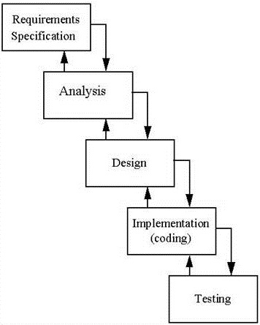

Project Management plan is as follows

**4.1.1. Requirement Specification**

We went through a lot of surveys over the internet which made us come to the conclusion that

* Internet penetration is little in rural areas
* Internet Awareness is rural areas is less too
* Mobile penetration is large
* People in these areas constituting 70% of our population crave for information.

This led us to the conclusion that information from the rich internet source needed to be provided to the users via the comparatively cheaper mobile source.

**4.1.2 Analysis**

In this phase, we surveyed the existing source of information namely the internet and gave its drawbacks while proposing a solution of our own for the problems encountered. We also listed our hardware and software specifications in this stage

**4.1.3 Design**

In the design phase we gave the and the functional view of the software. A number of diagrams including the use case diagram, activity diagram, deployment diagram and sequence diagram were used to model the software.

**4.1.4 Coding**

This phase shall be carried out in the next semester wherein we will write code for the following

* Automated server to receive messages via AT commands
* Search the information for the keyword over Wikipedia
* Obtain the parsed summary
* Store this summary in a database
* Convert this summary into audio
* Call back the user using AT commands to deliver the information in speech format.

**4.1.5 Testing**

This phase shall be carried out in the next semester. We shall be following a testing program that will involve unit testing, integration testing, and validation testing. We will test the proposed system for the following

* Whether the database that we maintain will be more optimal if it contains the parsed summary information or if it contains the audio file.
* Various unique keywords will be tested on Wikipedia to see if they give an error, and if they do, of what kind.

**4.2 STEPS TO BE FOLLOWED**

Step-1:

User will send a SMS consisting of the keyword regarding the query to a pre-specified number of an automated server.

Step-2:

This SMS is received at the server end on a modem enabled cell phone which is connected to server.

Step-3:

Content of SMS will be extracted by the automated server using AT commands.

Step-4:

This extracted keyword is now put on INTRENET i.e. Wikipedia website for getting the information related to it.

Step-5:

Now this information is stored on server temporarily as HTML o/p. And then this information is parsed using HTML parser.

Step-6:

This parsed information is now converted into audio format using Java Speech API.

Step-7:

A cache is maintained in which recently fired query’s results are stored. This will increase the efficiency of the system.

Step-8:

This converted audio format will be relayed to user on voice call made by using AT commands.

**5. DESIGN**

**5.1 FUNCTIONAL DIAGRAMATIC VIEW**

**5.1.1. Sequence Flow Diagram:**

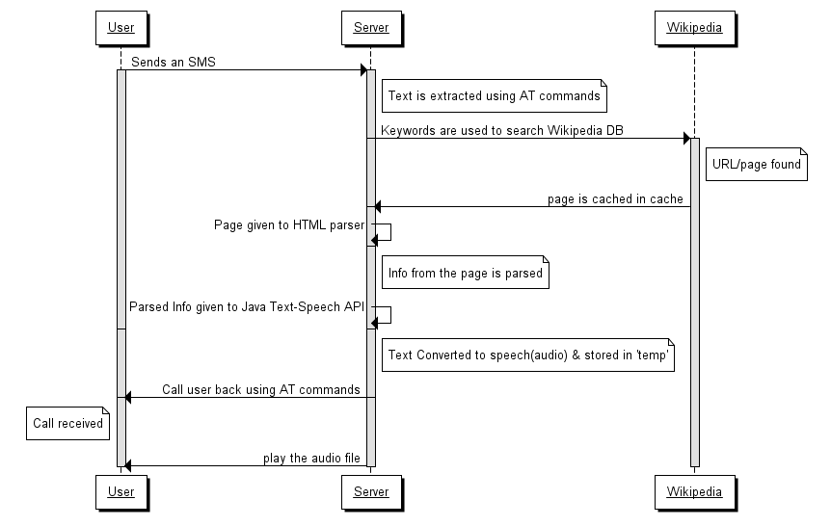

**5.1.2 Activity Diagram**

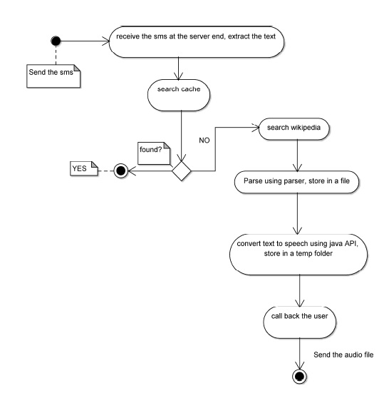

**5.1.3 Deployment Diagram**

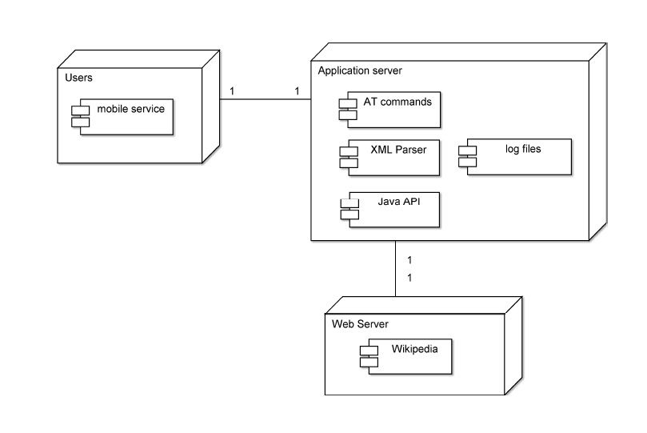

**6. TIMELINE & WORK BREAKDOWN**

**6.1 WORK BREAKDOWN AMONG MEMBERS**

|  |  |  |  |  |  |
| --- | --- | --- | --- | --- | --- |
| Month | Nelson D’souza. | | Abhishek Joshi. | | Jayesh Mone. |
| JULY | Initially Searched for Different  Topics for project | | Initially Searched for Different  Topics for project | | Initially Searched for Different  Topics for project |
| JULY | Found a Topic ‘Voice Wiki’ on the website ‘www.engineeringproject.org’ | |  | |  |
| JULY | Discussed Among project members regarding topic. | | Initially Searched for Different  Topics for project | | Initially Searched for Different  Topics for project |
| JULY | Work on the Abstract of project and Submit it. | | Work on the Abstract of project and Submit it. | | Work on the Abstract of project and Submit it. |
| JULY | Meet Project Guide and Discuss topics regarding project | | Meet Project Guide and Discuss topics regarding project | | Meet Project Guide and Discuss topics regarding project |
| AUGUST | Study Existing System And Give Basic Design of Proposed System. | | Study Existing System And Give Basic Design of Proposed System. | | Study Existing System And Give Basic Design of Proposed System. |
| AUGUST | Check Operational Feasibility. | | Check Economical Feasibility. | | Check Technical Feasibility. |
| AUGUST | Study The Requirements of the Project. And perform Requirement Analysis. | | | Study Requirements of the Project. And perform Requirement Analysis. | Study Requirements of the Project. And perform Requirement Analysis. |
| SEPTEMBER | Study The Wikipedia website for its Output to Various queries. | | | Study AT commands and Working of AT commands with Different Cell Phones. | Study Java Speech API and Method of Converting Text to Speech. |
| SEPTEMBER | Check the Output Page Code provided by Wiki Site as result of any query. | | | Check different AT commands for Receiving SMS and Making Calls. | Check Different types characteristics of API such as Sound types, Quality, Time Lag |
| SEPTEMBER | Design Snippet in Java to extract Introduction From Wiki output. | | | Check Hardware Compatibility of Cell Phone With Server PC And AT Commands. | Check The API for its Output when Wiki Extract is fed as Output. |
| SEPTEMBER | Draw Conclusions and Plan use of Wikipedia as Source of information. | | | Draw Conclusions and Plan use of AT Commands to Extract SMS and Make Calls. | Draw Conclusions and Plan use of Java Speech API For Text to Voice Conversion. |
| OCTOBER | Prepare Initial PowerPoint Presentation for Project | | | Prepare Initial Block Diagrams And UML Diagrams for Project. | Prepare Initial Synopsis And Documentation for Project. |
| OCTOBER | Verify the content from Project Guide. | | | Verify the content from Project Guide. | Verify the content from Project Guide. |
| OCTOBER | | Make the required corrections and give Internal Presentation. | | Make the required corrections and give Internal Presentation. | Make the required corrections and give Internal Presentation. |

**6.2 PROJECT TIMELINE**

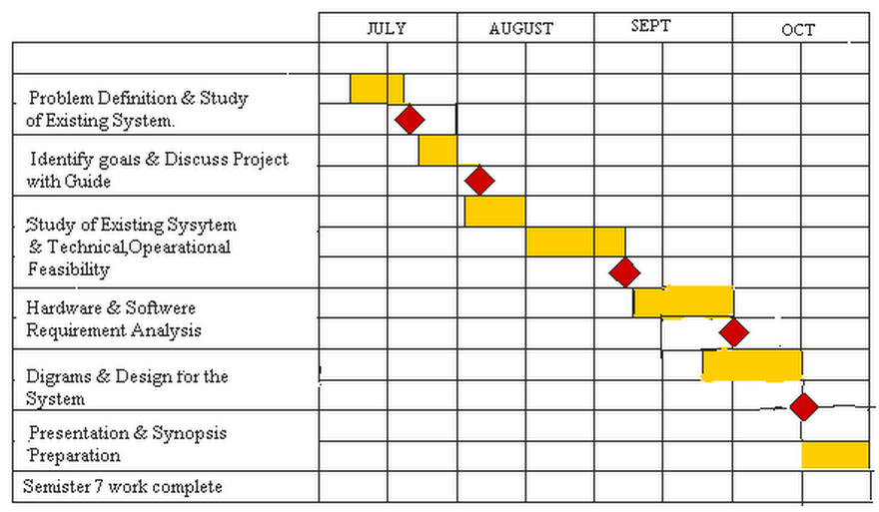

**6.3 IMPLEMENTATION PLAN FOR NEXT SEMESTER**

6.3.1. Deign Java Code for Checking the SMS arrival at the Server End.

6.3.2. Use AT Commands to extract the content of SMS received.

6.3.3. Design Java Code for searching the Web using keyword extracted from SMS.

6.3.4. Write Java Code for extracting HTML output from Wikipedia.

6.3.5. Write Java Code to parse the output obtained to get the first paragraph.

6.3.6. Write code to temporary store files.

6.3.7. Write code for Text to Speech Conversion using Java Speech API.

6.3.8. Write code for making a call back to user using AT commands.

6.3.9. Design Test Cases for each phase.

6.3.10. Perform Testing.

**7. REFERENCES**

**7.1 Books:**

7.1.1 Herbert Schildt: “The Complete Reference Java 2” Fifth Edition, TATA McGraw Hill. .

**7.2 Websites:**

**7.2.1 Requirement Elicitation**

7.2.1.1 <http://trak.in/tags/business/2010/04/07/internet-usage-india-report-2010/>

7.2.1.2 <http://www.dnaindia.com/mobile/report.php?n=1437531>

7.2.1.3 <http://www.e-agriculture.org/uploads/media>

7.2.1.4 <http://www.engineeringproject.org>

**7.2.2 Analysis & Design**

7.2.2.1 <http://www.developershome.com/sms/howToReceiveSMSUsingPC.asp>

7.2.2.2 <http://www.developershome.com/sms/sendSmsByAtCommands.asp>

7.2.2.3 <http://www.control.com.sg/at_commands_sms.aspx>

7.2.2.4 <http://nds1.nokia.com/phones/files/guides/Nokia_AThelp.pdf>

7.2.2.5 [www.java.sun.com/products/java-media/speech/](http://www.java.sun.com/products/java-media/speech/)

7.2.2.6 <http://www.mysqlperformanceblog.com>

7.2.2.7 <http://msdn.microsoft.com/en-us/library/ms720163(VS.85).aspx>

7.2.2.8 [http://www.wave-report.com/tutorials/](http://www.wave-report.com/tutorials/TTS.htm)

7.2.2.9 <http://onjava.com/pub/a/onjava/2004/09/08/IRCinJava.html>

7.2.2.10 [www.wikipedia.com](http://www.wikipedia.com)

**ACKNOWLEDGEMENT**

Consistent with the level of presentation every effort has been made to ensure that material included in this synopsis stand up to the expectations. In creating a system of high complexity, guidance plays an invaluable role. With great Pleasure we take this opportunity to acknowledge our gratitude to –

**Prof. Anup. Kunte (Project Guide),**

**Mrs. Ashwini Borle (Project Co-guide),**

**Prof. S.M. Patil (H.O.D. Computer)**

for their utmost support in building this synopsis.

We are also thankful to our college, for providing the infrastructure, and to **Principal Dr. M. B. Lele** for his support.

Without faith and constructive suggestions and guidance from all these people, this project could not be possible.

**APPENDIX**

**GSM: GLOBAL SYSTEM FOR MOBILE COMMUNICATION**

**API: APPLICATION PROGRAMMING INTERFACE**

**EDGE: ENHANCED DATA-RATE FOR GPRS EVOLUTION**

**GPRS: GENERAL PACKET RADIO SERVICE**

**SMS: SHORT MESSAGE SERVICE**

**JDK: JAVA DEVELOPMENT KIT**

**ITU: INTERNATIONAL TELECOMMUNICATION UNIT**

**TRAI: TELECOM REGIULATORY AUTHORITY OF INDIA**

**ICT: INFORMATION AND TELECOMMUNICATION TECHNOLOGY**

**CSD: CIRCUIT SWITCHED DATA**

**JSML: JAVA SPEECH API MARK-UP LANGUAGE**

**JSGS:JAVA SPEECH API GRAMMER FORMAT**

**ETSI: EUROPEAN TELECOMMUNICATION STANDARD INSTITUTE**

**CDPD: CELLULAR DIGITAL PACKET DATA**

**3GPP: THIRD GENERATION PARTNERSHIP PROJECT**